# **7.2 Guided Exercise: Password Policies**

|  |  |
| --- | --- |
| **Resources** | |
| Files | None |
| Machines | Windows Server |

In this exercise you will create a new user account and set its password policies.

Login to Windows Server, click the Start button, write gpedit.msc and press Enter.

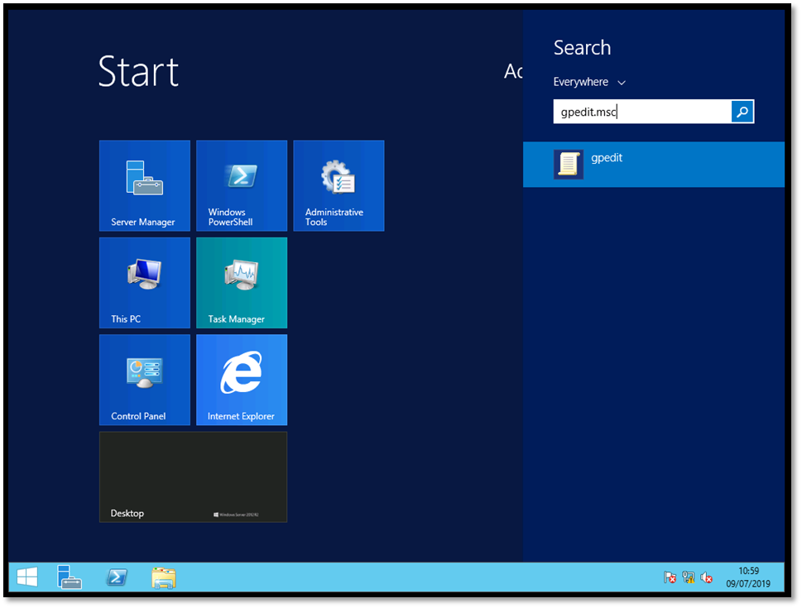

The Local Group Policy Editor window will open. Below Computer Configuration exand the folders Windows Setiings -> Account Policies.

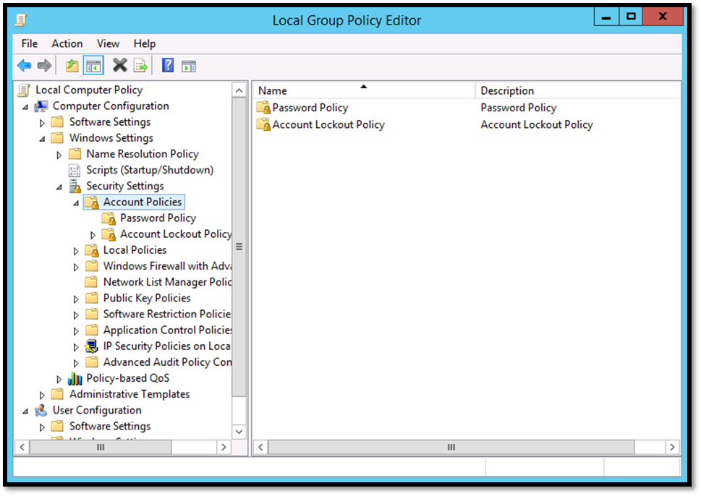

Click on the Password Policy and then right click on the Minimum password length and select properties.

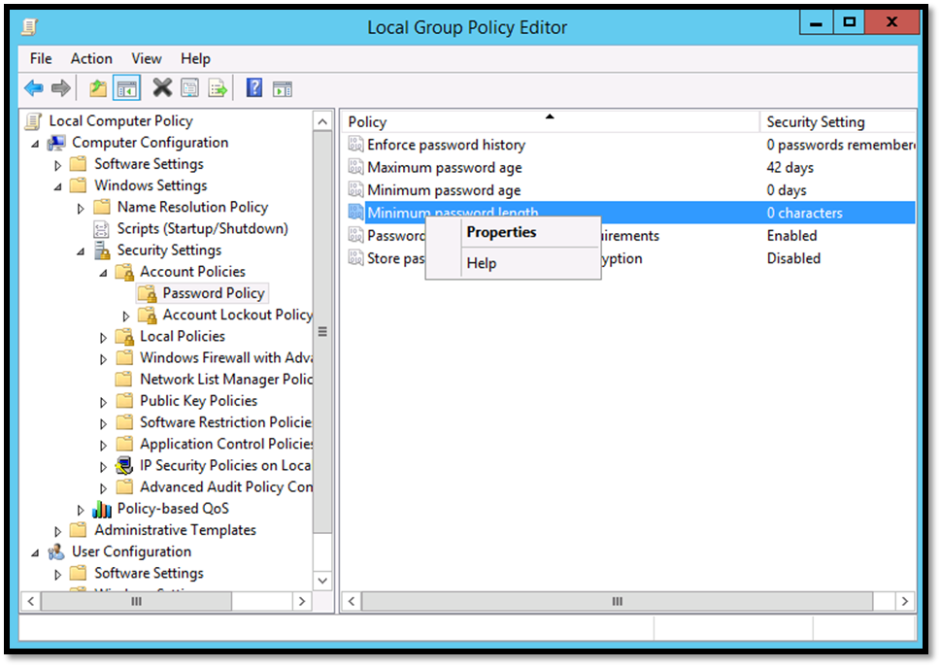

On the Minimum password length Properties window change the value 0 to 8, click Apply and then OK. Then close the Local Group Policy Editor.

